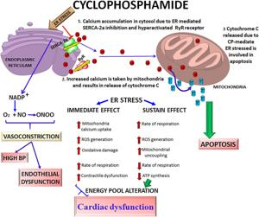
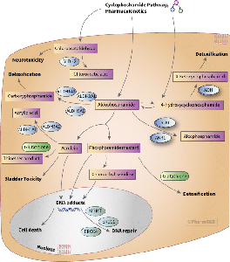
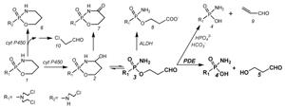
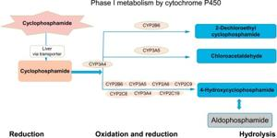
Cyclophosphamide is a chemotherapy and immunosuppressive drug widely used for the treatment of several cancers—such as lymphoma, leukemia, breast cancer, ovarian cancer, multiple myeloma, small cell lung cancer, and sarcoma—as well as non-cancerous conditions including nephrotic syndrome, ANCA-associated vasculitis, and complications following organ transplantation1257.
Mechanism of Action
- Cyclophosphamide is a prodrug that requires activation in the liver by cytochrome P450 enzymes68.
- Its active metabolite, phosphoramide mustard, forms irreversible cross-links between and within DNA strands (primarily at the guanine base), which disrupts DNA replication and transcription13467.
- This DNA damage leads to cell cycle arrest and programmed cell death (apoptosis) in rapidly dividing cells, including cancerous and certain immune cells236.
- Cyclophosphamide also has immunomodulatory effects, notably eliminating regulatory T cells and enhancing anti-tumor immunity in certain dosing strategies129.
Administration
- Cyclophosphamide can be given orally (as tablets) or by intravenous infusion (IV drip or injection)15.
- It is sometimes administered via central lines, PICC lines, or portacaths for repeated infusions5.
Major Indications
- Cancers: Lymphoma, leukemia, breast and ovarian cancer, small cell lung cancer, multiple myeloma, sarcoma1257.
- Immunosuppression: Used in nephrotic syndrome, vasculitis (including ANCA-associated vasculitis), and after organ transplant1257.
Common Side Effects
- Bone marrow suppression: Low white blood cell count, increasing risk of infection125.
- Gastrointestinal: Loss of appetite, nausea, vomiting12.
- Alopecia: Hair loss12.
- Bladder toxicity: Bleeding from the bladder (hemorrhagic cystitis) due to the toxic metabolite acrolein12.
- Long-term risks: Infertility, increased risk of secondary cancers (such as bladder cancer and leukemia), and pulmonary fibrosis12.
- Other: Cardiac dysfunction, ovarian failure, allergic reactions125.
Special Notes
- Due to its serious bladder toxicity, patients are often given mesna and increased hydration to prevent hemorrhagic cystitis.
- Careful monitoring of blood counts and organ function is essential throughout treatment125.
- The immunosuppressive actions make infection monitoring critical during therapy.
Summary of Key Properties
- Type: Alkylating agent (nitrogen mustard derivative)18.
- Onset: Rapid, with action felt in days to weeks in immunosuppression2.
- Cell-cycle activity: Cell cycle non-specific—targets both resting and dividing cells37.
- Approval: First approved in 1959, and is on the WHO list of essential medicines1.
Cyclophosphamide remains an essential component in both oncology and rheumatology due to its broad effectiveness against malignant and immune-mediated diseases, balanced against a significant side effect profile requiring careful clinical management.
- https://en.wikipedia.org/wiki/Cyclophosphamide
- https://www.youtube.com/watch?v=bwuM5F7tPCs
- https://go.drugbank.com/drugs/DB00531
- https://www.ncbi.nlm.nih.gov/books/NBK553087/
- https://www.cancerresearchuk.org/about-cancer/treatment/drugs/cyclophosphamide
- https://onlinelibrary.wiley.com/doi/full/10.1002/jcc.27280
- https://www.sciencedirect.com/topics/pharmacology-toxicology-and-pharmaceutical-science/cyclophosphamide
- http://www.bccancer.bc.ca/drug-database-site/drug%20index/cyclophosphamide_monograph_1june2013_formatted.pdf
- https://pubmed.ncbi.nlm.nih.gov/26620820/
- https://www.mdpi.com/2218-0532/88/4/42

